|  |
| --- |
| **Project developing phase Sprint 3** |
| **Team id : PNT2022TMID38300**  **Project name: emerging method for early detection of forest fires** |

**IDENTIFY THE PROBLEM**

* **Forest fires cause lots of damage, some of them are – loss of wildlife habitat, extinction of plants and animals, destroys the nutrient rich top soil, reduction in forest cover, loss of valuable timber resources, ozone layer depletion, loss of livelihood for tribal people and poor people, increase in global warming, increase in carbon dioxide content in the atmosphere, degradation of catchment areas, loss of biodiversity, increase in diseases etc**

**ABSTRACT**

* Our model considers a new element in forest fire modeling, namely the dynamics of a forest animal, intimately linked to the trees. We show that animals and trees react differently to different types of fire. A high probability of fire initiation results in several small fires, which do not allow for a large fuel accumulation and thus the destruction of many trees by fire, but is found to be generally devastating to the animal population at the same time. On the other hand, a low fire initiation probability allows for the accumulation of higher quantities of fuel, which in turn results in larger fires, more devastating to the trees than to the animals. Thus, we suggest that optimal fire management should take into account the relation between fire initiation and its different effects on animals and trees.

**PROBLEM STATEMENT**

* **Surface Fire** - A forest fire may burn primarily as a surface fire, spreading along the ground as the surface litter (senescent leaves and twigs and dry grasses etc) on the forest floor and is engulfed by the spreading flames.
* **Underground Fire** - The fires of low intensity, consuming the organic matter beneath and the surface litter of forest floor are sub-grouped as underground fire. In most of the dense forests a thick mantle of organic matter is find on top of the mineral soil. This fire spreads in by consuming such materials. These fires usually spread entirely underground and burn for some meters below the surface. This fire spreads very slowly and in most of the cases it becomes very hard to detect and control such type of fires. They may continue to burn for months and destroy vegetative cover of the soil. The other terminology for this type of fire is Muck fires.
* **Ground Fire -**These fires are fires in the sub surface organic fuels, such as duff layers under forest stands, Arctic tundra or taiga, and organic soils of swamps or bogs. There is no clear distinction between underground and ground fires. The smoldering under ground fires sometime changes into Ground fire. This fire burns root and other material on or beneath the surface i.e. burns the herbaceous growth on forest floor together with the layer of organic matter in various stages of decay. They are more damaging than surface fires, as they can destroy vegetation completely. Ground fires burn underneath the surface by smoldering combustion and are more often ignited by surface fires.
* **Crown Fire** - A crown fire is one in which the crown of trees and shrubs burn, often sustained by a surface fire. A crown fire is particularly very dangerous in a coniferous forest because resinous material given off burning logs burn furiously. On hill slopes, if the fire starts downhill, it spreads up fast as heated air adjacent to a slope tends to flow up the slope spreading flames along with it. If the fire starts uphill, there is less likelihood of it spreading downwards.
* **Firestorms** - Among the forest fires, the fire spreading most rapidly is the firestorm, which is an intense fire over a large area. As the fire burns, heat rises and air rushes in, causing the fire to grow. More air makes the fire spin violently like a storm. Flames fly out from the base and burning ember spew out the top of the fiery twister, starting smaller fires around it. Temperatures inside these storms can reach around 2,000 degrees Fahrenheit

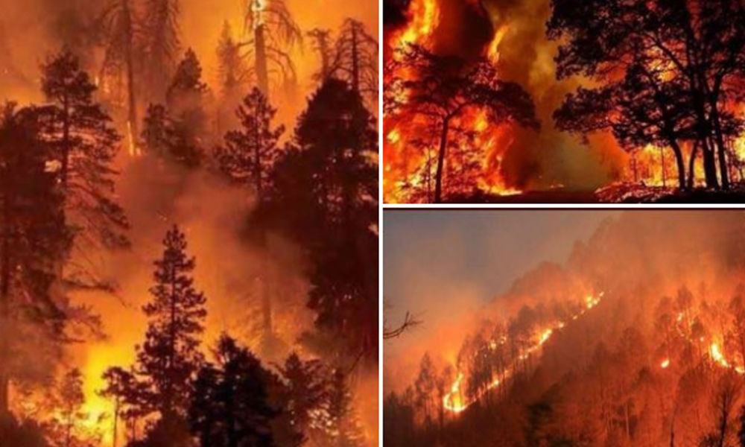

**The followings are the important precautions against fire:**

* To keep the source of fire or source of ignition separated from combustible and inflammable material.
* To keep the source of fire under watch and control.
* Not allow combustible or inflammable material to pile up unnecessarily and to stock the same as per procedure recommended for safe storage of such combustible or inflammable material.
* To adopt safe practices in areas near forests viz. factories, coalmines, oil stores, chemical plants and even in household kitchens.
* To incorporate fire reducing and fire fighting techniques and equipment